Name : Lokare Mahir Abdul Majeed

Roll no : 23AI34
Batch:02

EXPERIMENT NO- 9

AIM:
To study and implement the McCulloch-Pitts Model of artificial neuron for performing basic logical operations.
RESOURCE REQUIRED:
Google repository, Dataset, Jupyter Notebook
THEORY:
The McCulloch-Pitts Model is one of the earliest artificial neural network models used to represent a biological neuron in a simplified mathematical form. It is a binary threshold-based model that takes inputs in the form of 0 and 1 and produces an output of either 0 or 1 depending on a threshold value.
The model consists of excitatory inputs (positive weights) and inhibitory inputs (negative weights). If the weighted sum of inputs exceeds a certain threshold, the neuron activates and produces output 1, otherwise it produces output 0.
It helps in understanding the basic working of neural networks and can be used to implement logical operations like AND, OR, and NOT.
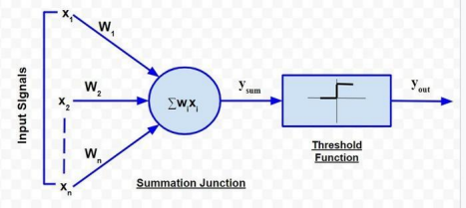
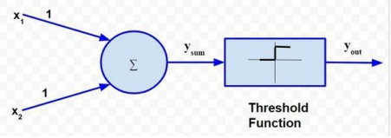
Wo
Ranking of McCulloch-Pitts Model:
The McCulloch-Pitts neuron works using a simple mathematical approach where inputs are multiplied by weights and then passed through a threshold function to generate output.
Step 1: Input Representation
The neuron receives multiple binary inputs such as: x₁, x₂, x₃, …, xₙ
Each input can have a value of either 0 or 1 representing inactive or active state.
Step 2: Assign Weights
Each input is associated with a weight:
w₁, w₂, w₃, …, wₙ
Excitatory inputs have positive weights and increase the activation of the neuron, while inhibitory inputs have negative weights and decrease the activation.
Step 3: Calculate Weighted Sum
The neuron computes the weighted sum of all inputs using:
ysum = ∑ (wᵢ xᵢ)
This step combines all inputs into a single value which represents the total activation of the neuron.
Step 4: Apply Threshold Function
The output of the neuron is determined using a threshold function:
yout = 1, if ysum ≥ θ
yout = 0, if ysum < θ
where θ is the threshold value.
Step 5: Output Generation
Based on the threshold condition, the neuron produces a binary output (0 or 1). This output can be used to represent logical decisions.
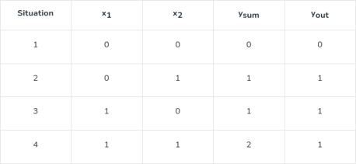
Thus, we see that for a data set with linearly separable classes, perceptrons can always be employed to solve classification problems using decision lines (for 2-dimensional space), decision planes (for 3-dimensional space) or decision hyperplanes (for n-dimensional space). Appropriate values of the synaptic weights can be obtained by training a perceptron. However, one assumption for perceptron to work properly is that the two classes should be linearly separable i.e. the classes should be sufficiently separated from each other. Otherwise, if the classes are non-linearly separable, then the classification problem cannot be solved by perceptron.
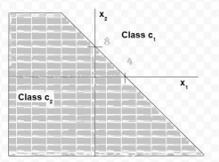
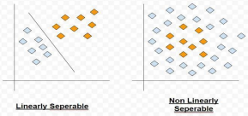
Multi-layer perceptron: A basic perceptron works very successfully for data sets which possess linearly separable patterns. However, in practical situations, that is an ideal situation to have. This was exactly the point driven by Minsky and Papert in their work in 1969. They showed that a basic perceptron is not able to learn to compute even a simple 2 bit XOR. So, let us understand the reason.
Consider a truth table highlighting output of a 2 bit XOR function

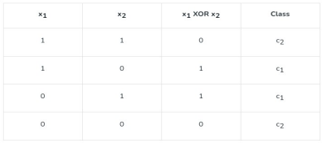
The data is not linearly separable. Only a curved decision boundary can separate the classes properly. To address this issue, the other option is to use two decision boundary lines in place of one.
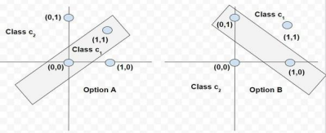

IMPLEMENTATION -
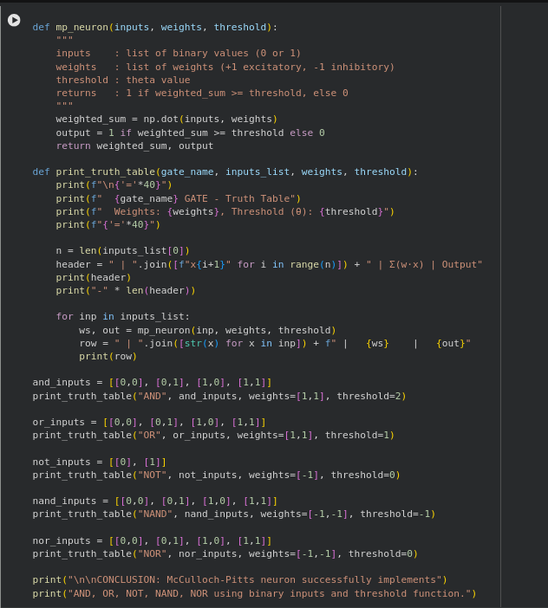

OUTPUT -
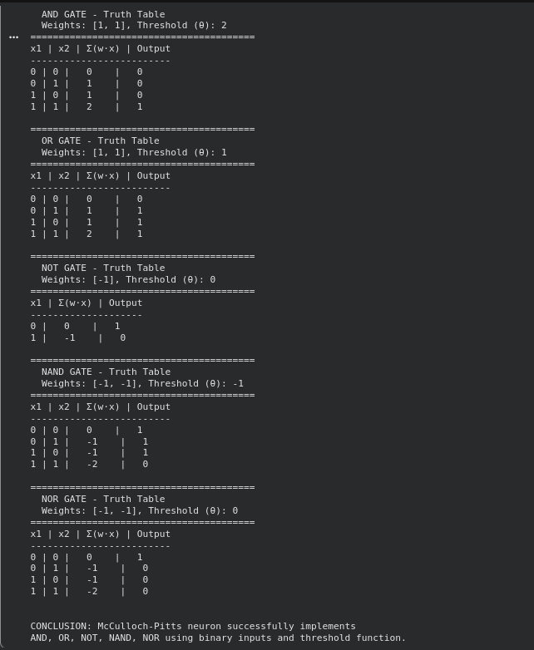

CONCLUSION –
Hence we have studied and implemented the McCulloch-Pitts Model which is a basic artificial neuron model.
The model successfully performs logical operations using binary inputs and threshold function. Thus, it forms the foundation for understanding more complex neural network models.

